

**CMD TEAM FUND COLLATION APPLICATION DESIGN PLAN**

**PROGRAMMERS:** Ebo Richard M.

Chukwuma Ebube

Franklin Chinyere

Ikechukwu Michael

Igboekwulisi Franklin

**APPLICATION NAME:** CMD Monthly Fund Collation App

**APPLICATION TYPE:** Desktop Application

**LANGUAGE:** JAVA

**TOOLS:** IntelliJ IDEA, SceneBuilder, Jdk 8, Jfx jdk, animateFX, Github, Launch4j.

**APPLICATION CYCLE DESCRIPTION**

This application is a standalone application, and would be integrated to use the web in the long run. Hence only an individual is intended to make use of the application at the start stage. Below is a brief description of the application cycle.

Stage 1: When the app is launched, for the first time, the first thing to be seen is the **SPLASH SCREEN**. Here, the CMD logo and motto is displayed in the form of an animation with the message “Welcome to CMD”, then an arrow to proceed.

Stage 2: This stage is the **MAIN APPLICATION**. It consists majorly of four buttons namely, “Add New Member”, “View Member Record”, “Add Payment Record”, “About CMD”, and the pictures, names and other relevant details of each member in the team.

The “Add New Member” button adds a new member record; this is the case of new intakes to the team. This shows something like a sign up page and asks for the necessary details to add the new member.

The “View Member Record” button is used to view a selected member’s financial record.

The “Add Payment Record” button is used to add a new financial record to a selected member. This button displays a dialog that accepts the amount and month paid for by the selected member. After record is made, a dialog pops up showing that the record has been entered successfully.

The “About CMD” button displays an animation of all the tenets of the team, ranging from the team constitution, the aims and goal of the team, it’s current members etc.

**PS:** Every process in this stage has a return button to opt out of any option already entered.

**SUGGESTED IMAGES FOR DESIGN**

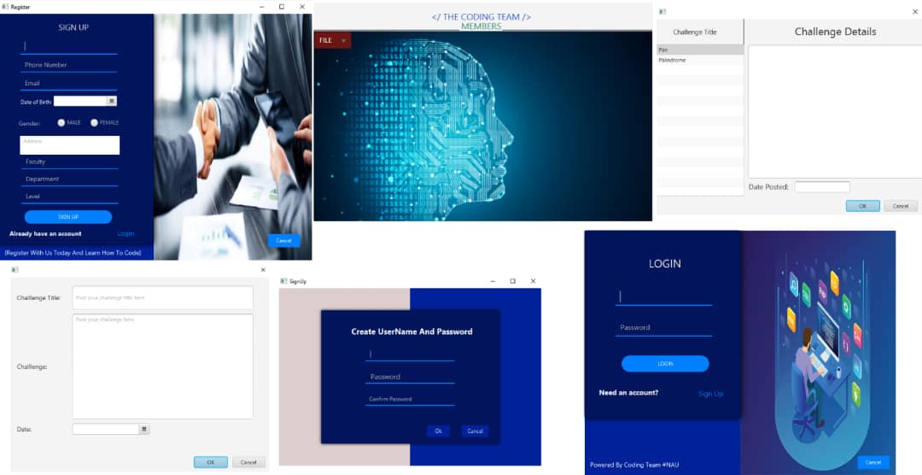

**Figure1: Suggestion by Igboekwulisi Franklin(splash screen, sign up, login e.g)**

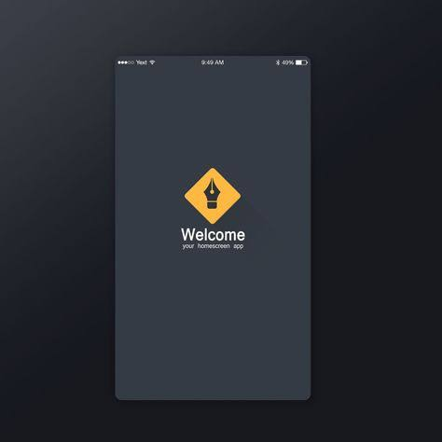

**Figure 2: Suggestion by Ebo Richard (Splash screen sample)**